|  |
| --- |
| **Endocrine System -** Practice Examination Questions |

**Multiple-Choice Section (15 marks)**

Suggested working time is 15 minutes

_________________________________________________________________________________

1. Often a number of hormones can be involved in maintaining the same aspect of homeostasis. Which of the following is correct?
2. Parathyroid hormone and aldosterone regulate the amount of calcium in the blood.
3. Adrenalin, glucagon and insulin regulate the glucose level of the blood.
4. Thyroxine and ACTH helps maintain salt and water balance in the body.
5. Cortisol and ADH decrease the rate of oxygen use by some cells.

2. Which of the following hormones does not affect blood glucose levels?

(a) Thyroxine

(b) Cortisol

(c) Aldosterone

(d) Adrenaline

3. Anti-diuretic hormone is produced in the

(a) anterior pituitary gland.

(b) posterior pituitary gland.

(c) hypothalamus.

(d) medulla oblongata.

1. Which of the following pairings of an endocrine gland with its secretory product is incorrect?
2. Anterior Pituitary– Progesterone
3. Posterior Pituitary – Oxytocin
4. Adrenal Cortex – Cortisol
5. Pancreas – Insulin

5. Which of the following lists of symptoms could indicate hypothyroidism?

* 1. unexplained weight gain or loss, slow heart rate, goitre
  2. slow heart rate, fatigue, weight gain
  3. unexplained weight loss, accelerated heart rate, fatigue
  4. increased appetite, fatigue, sweating

6. Which of the following best describes signal transduction?

1. the secretion of hormones from the hypothalamus for storage in the posterior pituitary gland
2. the activation of a protein via signaling molecule called secondary messengers
3. the process through which a protein hormone enters the target cell
4. the binding of a steroid hormone with its membrane receptor.
   * 1. Sleep is regulated by the
5. thymus gland.
6. thyroid gland.
7. pineal gland.
8. adrenal gland.

8. Which of the following hormones is secreted as a response to long-term stress?

1. adrenaline
2. cortisol
3. noradrenaline
4. glucagon

**Question 9 and 10 refer to the diagram below.**

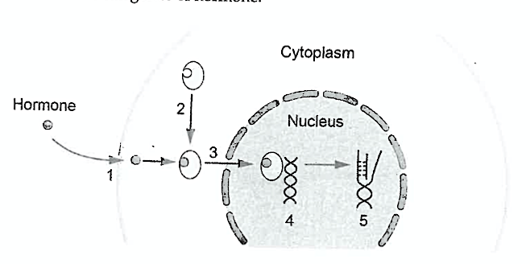

9. The hormone depicted in the diagram above is a

* 1. lipid-soluble hormone
  2. steroid hormone
  3. water-soluble hormone
  4. both a and b are correct

10. Point 4 on the diagram depicts

1. Hormone binding to the membrane receptor
2. Hormone binding to the receptor inside of the cell
3. Hormone-receptor complex activating genes
4. Transcription

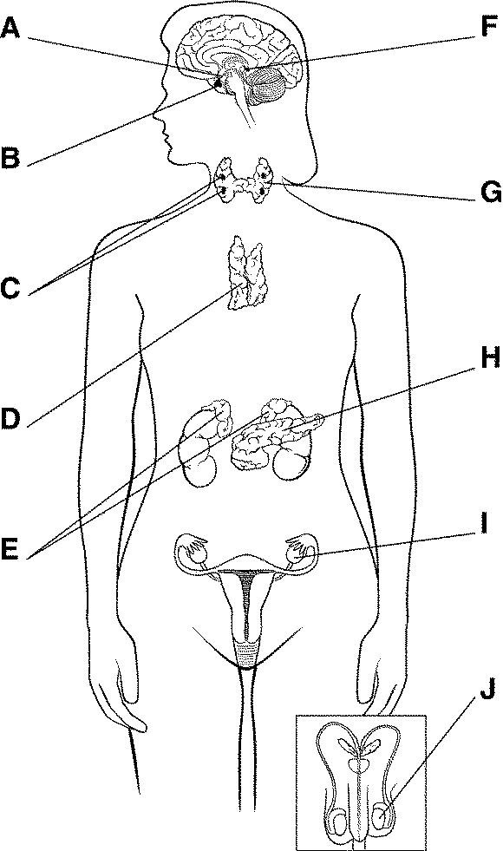**Question 10 and 11 refer to the diagram to the right**

10. Which of the following correctly identifies the endocrine

glands in the diagram?

|  |  |  |  |  |
| --- | --- | --- | --- | --- |
|  | **C** | **D** | **F** | **E** |
| (a) | Thyroid | Pancreas | Hypothalamus | Adrenal glands |
| (b) | Thymus | Thyroid | Pituitary | Pancreas |
| (c) | Parathyroids | Ovaries | Hypothalamus | Pancreas |
| (d) | Parathyroids | Thymus | Pineal | Adrenal glands |

11. Which of the following hormones is **not** produced by Gland E?

1. Cortisol
2. Aldosterone
3. Adrenaline
4. Androgens

13. The overproduction of thyroxine is referred to as:

1. hypothyroidism
2. hyperthyroidism
3. achondroplasia
4. cretinism

14. What controls nearly all secretions from the pituitary gland?

1. Only hormonal signals from the hypothalamus
2. 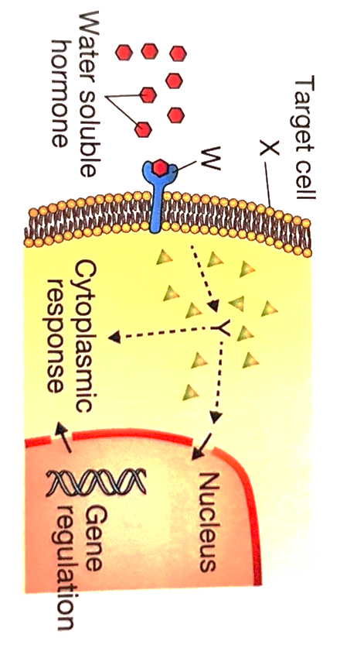Only nervous signals from the hypothalamus
3. Either hormonal or nervous signals from the hypothalamus
4. Signals from the sensory organs?

**Question 15 refers to the diagram below**

15. Identify W, X and Y.

|  |  |  |  |
| --- | --- | --- | --- |
|  | **W** | **X** | **Y** |
| (a) | Receptor | Membrane | Signal transduction |
| (b) | ATP | Receptor | Signal translation |
| (c) | Receptor | Membrane | Signal transduction |
| (d) | Membrane | Receptor | Signal translocation |

**Short Answer Section (25 marks)**

Suggested working time is 25 minutes

__________________________________________________________________________________

**Question 16 (9 marks)**

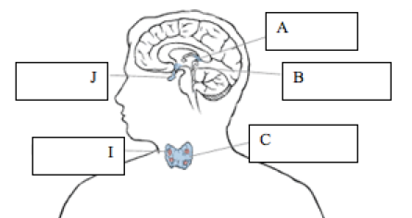

(a) Use the above diagram to complete the table below. You must identify the name of the gland, a hormone produced by the gland and the effect of the hormone. (6 marks)

|  |  |  |  |
| --- | --- | --- | --- |
| **Gland** | **Name of Gland** | **Example of hormone produced** | **Effect of Hormone** |
| C |  |  |  |
| I |  |  |  |

1. The structure labelled J is the pituitary gland. The pituitary gland is often referred to as the “master gland”.

Explain, using specific hormone(s) as an example, why this is the case. (3 marks)

______________________________________________________________________________________________________________________________________________________________________________________________________________________________________________________________________________________________________________________________________________________________________________________________________________________________

**Question 17 (10 marks)**

The diagram below is an illustration of the pituitary gland and two of its hormones.

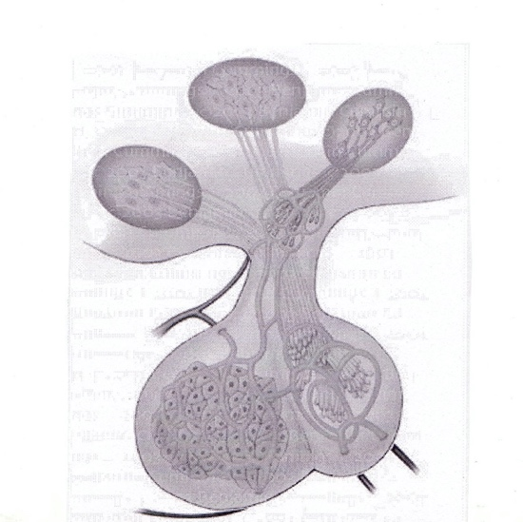

##### Oxytocin

##### Luteinising

hormone

(a) (i) Describe the effects of luteinising hormone (1 mark)

_____________________________________________________________________

__________________________________________________________________________________________________________________________________________

(ii) Describe the effects of oxytocin. (1 mark) _____________________________________________________________________

__________________________________________________________________________________________________________________________________________

(b) Describe the difference in the **production** and **release** of these two hormones.

(4 marks)

______________________________________________________________________________________________________________________________________________________________________________________________________________________________________________________________________________________________________________________________________________________________________________________________________________________________

_____________________________________________________________________

(c) Testosterone (a steroid hormone) and adrenaline (a protein hormone) are both hormones yet function very differently.

Describe how these two hormones differ in their mode of action.(4 marks)

______________________________________________________________________________________________________________________________________________________________________________________________________________________________________________________________________________________________________________________________________________________________________________________________________________________________

_____________________________________________________________________

_____________________________________________________________________

_____________________________________________________________________

**Question 18 (6 marks)**

Complete the table below to compare and contrast Diabetes mellitus Type 1 and Type 2.

|  |  |  |
| --- | --- | --- |
|  | **Type 1 diabetes** | **Type 2 diabetes** |
| Cause |  |  |
| How is insulin production of response to insulin affected? |  |  |
| Treatment |  |  |

**Extended Response (22 marks)**

Suggested working time is 25 minutes

__________________________________________________________________________________

**Question 18 (10 marks)**

(a) Describe **five (5)** ways in which the nervous system differs to the endocrine system in its response to stimuli.

Examine these differences with specific reference to the control mechanisms that increase internal heat production and conserve heat when the body is exposed to low external temperature.

(10 marks)

**Question 19 (12 marks)**

* 1. Describe the roles of the hypothalamus and pituitary gland and explain how they work together.

(12 marks)